**Hostel Accommodation**

The course is strictly residential. All students will be provided hostel accommodation in the school campus.

As you step into our hostel, you will find a warm and inclusive environment where students from diverse backgrounds come together in pursuit of their nursing education. Our rooms are designed to provide comfort and privacy, ensuring that you have a peaceful haven to rest and recharge after a day of rigorous study and clinical practice. Here, lifelong friendships are forged, where students support and uplift each other through the challenges of academic life. Our common areas are vibrant hubs of activity, where you can unwind, socialize, and engage in meaningful conversations with your peers. Being the part of a Catholic institution, we offer opportunities for prayer, Holy Mass and spiritual guidance and counselling, providing a supportive environment for students to nurture their faith and deepen their connection to something greater than themselves.

**GENERAL INSTRUCTIONS**

1. The student shall dress neatly and appear decent at all times in the school, hospital and community field.
2. Strict discipline is to be observed in the school, hostel and the hospital premises.
3. Communal harmony is to be preserved and fostered by all in ‘word and deed’.
4. The students have to attend all the spiritual activities according to the institutional horrarium.
5. The student who gets married or pregnant during the course of study will not be allowed to continue the course further.
6. Going out of the institution for any purpose shall be done only with the knowledge and permission of the principal or warden, in accordance with the rules of the hostel.
7. Possession of mobile phones, radio, and any electronic devices are strictly forbidden and if found firm action will be taken.
8. Use of alcohol and drugs is strictly forbidden in the hostel and Campus and strict action will be taken by the managing committee.
9. Misconduct, disobedience, inefficiency or negligence of study or duty is sufficient ground for dismissal from the Nursing course.
10. Any student, who discontinues the course for any reason in any time, will be liable to pay a sum of **75000/-** in compensation for the vacated seat.
11. All terms and conditions set forth in the Prospectus are liable to be revised whenever found necessary. The Management reserves the right to make necessary changes in the rules and regulations of the Institution.

**Visitation Policies**: There are set guidelines for visitation hours and who is allowed to visit the hosteler in the hostel.

**Quiet Hours**: During which noise levels should be kept to a minimum to allow for studying and rest.

**Room Maintenance**: Require hosteler to keep their rooms clean and tidy, and regular inspections are done.

**Respect for Others**: We teach and emphasize the importance of respecting fellow hostelers' privacy, belongings, and personal space.

**Safety and Security**: We Implement measures to ensure the safety and security of students such as locking doors at night and providing emergency contact information.

**Alcohol and Substance Use**: We have clearly outline policies regarding the consumption of alcohol and other substances within the hostel premises.

**Internet and Technology Usage**: We establish guidelines for the use of internet and electronic devices to promote responsible usage and respect for others' access.

**Personal Conduct**: Encourage students to conduct themselves in a respectful and professional manner at all times.

**Health and Hygiene**: Promote good hygiene practices and provide information on healthcare resources available to the students.

**Counselling and Support**: Providing support and guidance to residents who may be experiencing personal or academic challenges. This could involve referring them to appropriate resources such as counselling services or academic advisors.

**Emergency Procedures**: Educate students on what to do in case of emergencies such as fire, medical emergencies, or natural disasters.

**Community Engagement**: Encourage students to participate in hostel activities, community service, and other opportunities for personal and professional development.

**Compliance**: Clearly communicate that students are expected to comply with all hostel rules and regulations, and outline consequences for violations.

**School Mess**

The school mess often a bustling hub of activity, plays a vital role in the daily life of students. It provides not only a place to eat but also a social space where students can relax and interact. High standards of hygiene and food safety are maintained in the mess. This includes regular cleaning, proper food storage, and safe food preparation practices, with adequate seating and a comfortable environment for students to enjoy their meals. The Mess serves both vegetarian and non-vegetarian meals.

The mess is managed by a Mess Committee consisting of the student representatives and teaching staff. The Mess Committee shall respect the opinion of the majority and the final decisions shall be subjected to the consensus of the faculty in charge. The students are inducted to the mess committee on a monthly rotation basis, so as to give opportunity to almost all of them. The student members strictly supervise the activities in the mess at the time of every serving. Cleaning of the mess is also done under their supervision. If found necessary, these members will voluntarily does a final tidying work so as to ensure that the refectory is spick and span.

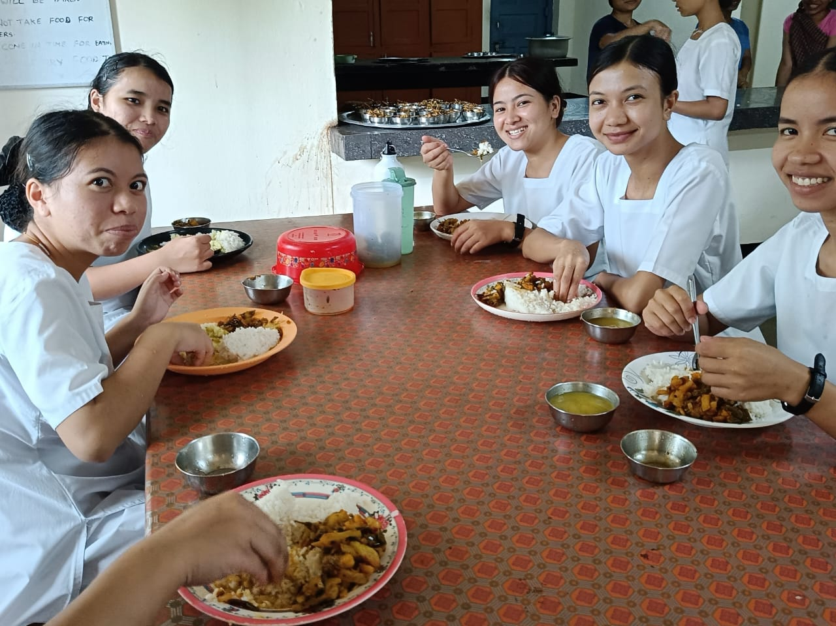

**Transport**

We have school bus for providing safe, reliable and efficient transportation during our academic related journeys. This enhances easy access to essential clinical experiences and community engagements together with promotion of inclusivity and safety. The bus service of the school addresses multiple needs, contributing to a more effective educational environment.

